For Art Lovers and Curious Minds
Free Local Art Tour for Friends of the Humanities
March 31, 2023

Take a friend to the Hilliard Museum on March 31, 2023 for a Friends of the Humanities guided tour in three galleries and the flex space. Admission is free! Masks are optional. There is no limit on the size of the group. Curator Ben Hickey will lead the tour.
Hilliard University Art Museum
710 E. St. Mary Boulevard
Lafayette, LA 70503

Friday, March 31, 2023
11 a.m. – 12 noon
Please pre-register online at https://forms.gle/WihfZ5XiNJhEsCVi7
Or call the Museum to indicate your desire to attend (337) 482-0811

Information on the exhibitions:

Gallery A: On the Verge: Luciana Abait
On the Verge is a somewhat surreal attempt to understand how humankind is impacted by a changing climate and water scarcity.

Gallery B: Envisioning the South: The Roger Houston Ogden Collection
Envisioning the South is a look at how Roger Ogden helped shape Southern aesthetics and art history.

Gallery C: Entangled: Recent Work by Kalee Appleton
Entangled features new work by Kalee Appleton that challenges notions of what fine art photography can be. Appleton's work also blurs the line between depicting landscapes and thinking about the digital world in a manner similar to how ecologists study the world.

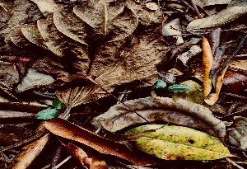
FlexSpace: Little Things: Drawings and Photographs by Fred Packard
Little Things is a small retrospective of Fred Packard's career. Packard notably founded the photography concentration in the Department of Visual Arts here on campus.

